Deliverable Report

HEI Project
HEI Project Name:
HEI Project start date:
Deliverable
Title: | Helsinki Innovation Ecosystem Mapping
Deliverable No.: | 1
Type of Deliverable | R
Authors: | Vertical, Lars Melakoski & Bogdana Gamburg
Level of completion (0 – 100) | 100% = fully achieved
Delivery date (due): | 30.12.2022
Due deliverable (actual): | 30.12.2022
Dissemination level | RD = Restricted dissemination for EIT and EIT Food internal use only

CONTENTS
1. Executive Summary 4
2. Deliverables 4
3. Annexes 4

Executive Summary
Vertical was to evaluate the innovation ecosystem at the University of Helsinki. The purpose was to map out the offering of the different innovation institutions functioning under the University. We were to map out what the different institutions offer, to whom and how they collaborate with each other, as well as how the innovation landscape looks like for the end-users.
The key finding was that the offering seemed to have overlaps, but we discovered that they were instead synergies. Clearer communication on who which organisations serve, for what purpose and how, are to be developed to strengthen the image of a unified Helsinki Innovation Ecosystem.

Deliverables
The project was initiated by Vertical interviewing the 4 main stakeholders - SPARK Finland, University of Helsinki, Helsinki Think Company and Terkko Health Hub. The purpose of the interviews was to understand the 4 organisations functions by a series of questions, see the detailed answers in the annexes:
- What does your organisation do, how and why?
- How do you communicate what you do? What do you communicate?
- Who do you communicate to?
- Who does your organisation serve?
- Do your customers understand what you provide?
- What are you good at?
- What do you need to improve?
- What do you do if a customer turns out to not be a great fit for your offering?
By conducting these interviews one-on-one, we gathered a baseline understanding of what the offerings look like and what possible synergies and overlaps are.
In addition to the interviews, Vertical conducted a light audit on the social media activities by the stakeholders (webpage, LinkedIn). This audit was used at the joint workshop to create a mutual understanding of what the stakeholders communicate and to whom, where possible overlaps and synergies may lie and whether they communicate their latest strategies.
The joint workshop was structured around the individual interviews, as a group going through the agenda based on the interviews:
- Who do we serve & what do we aim to provide?
- How do we serve our customers?
- Social media audit - this is what we show today
- What are the needs of our customers?
- What do we provide our customers?
- Why, how & what - the purpose of our organisations & our ecosystem.
The outcome of the session was positive - even though there seemed to be quite a bit of overlap based on the audit and initial interviews, the reality was much more nuanced. We managed to map out quite a clear “customer journey” for potential users of the services - each organisation has a relatively targeted audience and unique services they provide, but there is also a quite natural “growing journey” between the organisations. The main points of confusions are created by Terkko Health Hub and Helsinki Think Company providing both services and premises - meaning their customers might be early stage teams looking for guidance, or more mature companies looking for affordable office environments in a collaborative space.
The main takeaway is that the organisations should update their social media & webpages to match their most recent strategies, and as agreed in the joint workshop a section of what the “greater Helsinki Innovation Ecosystem” has to offer would be called for.

Annexes

3.1 Sparkhub Interview
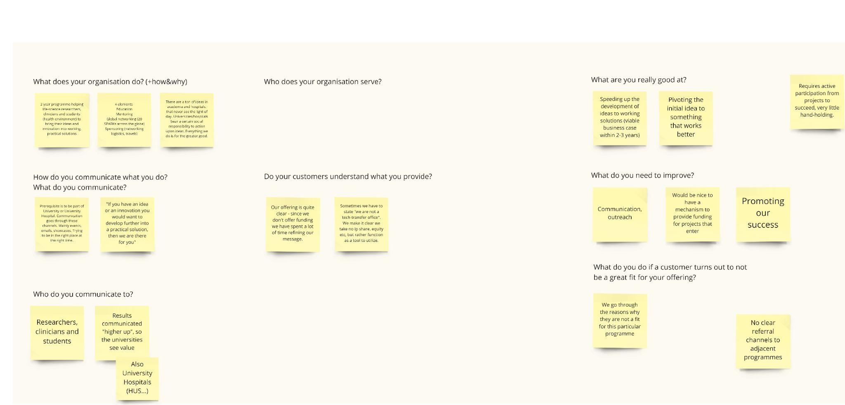

3.2 University of Helsinki Interview
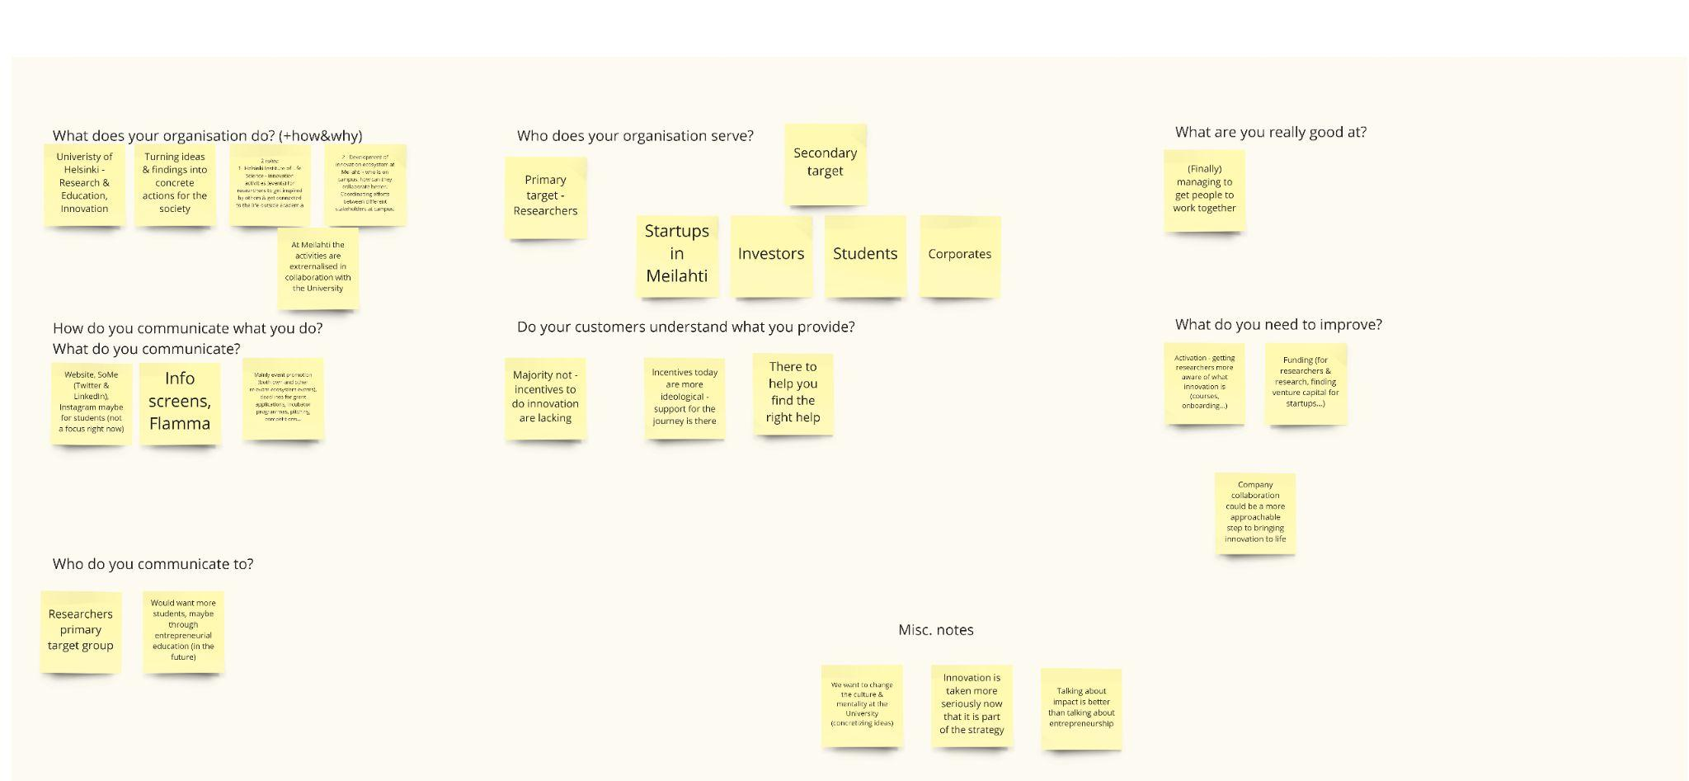

3.3 Think Company Interview
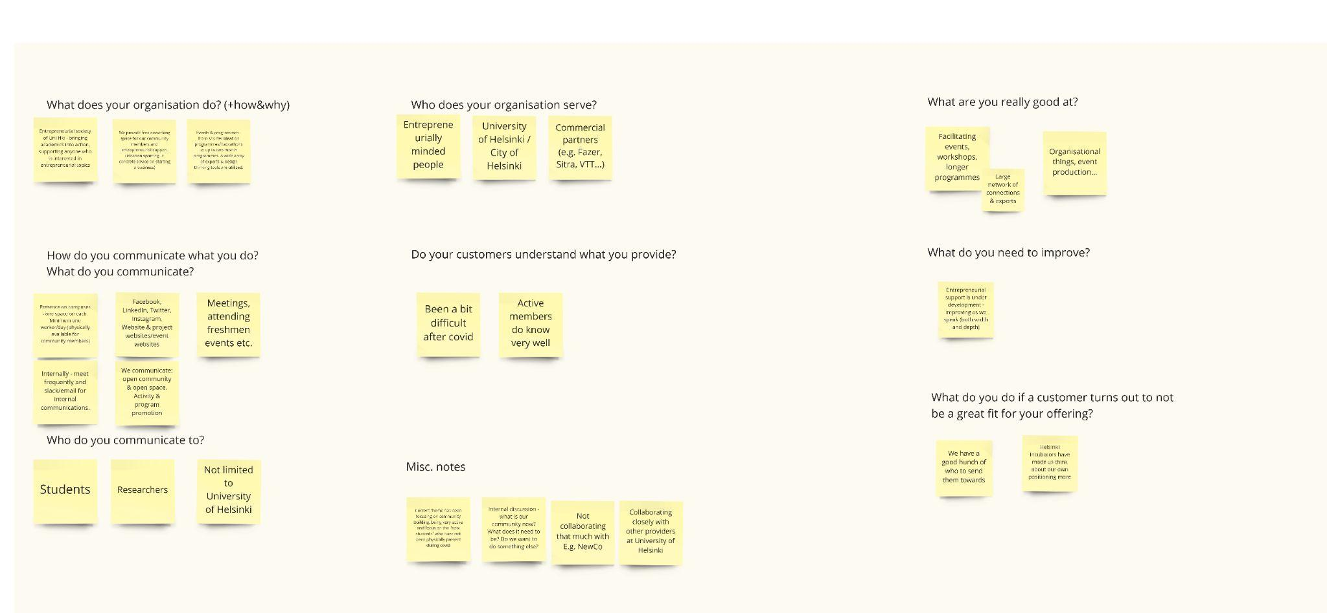

3.4 Terkko Interview
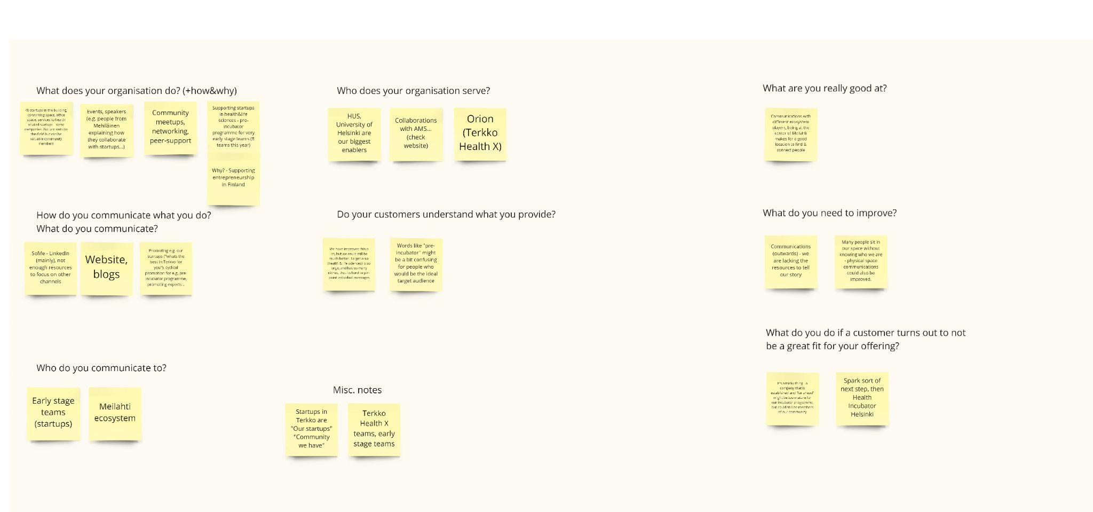

3.5 Target Audience and Customer Mapping across involved entities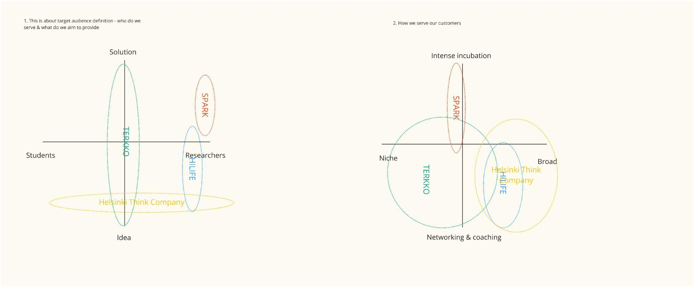

3.6 What we see today, publicly, across all involved stakeholders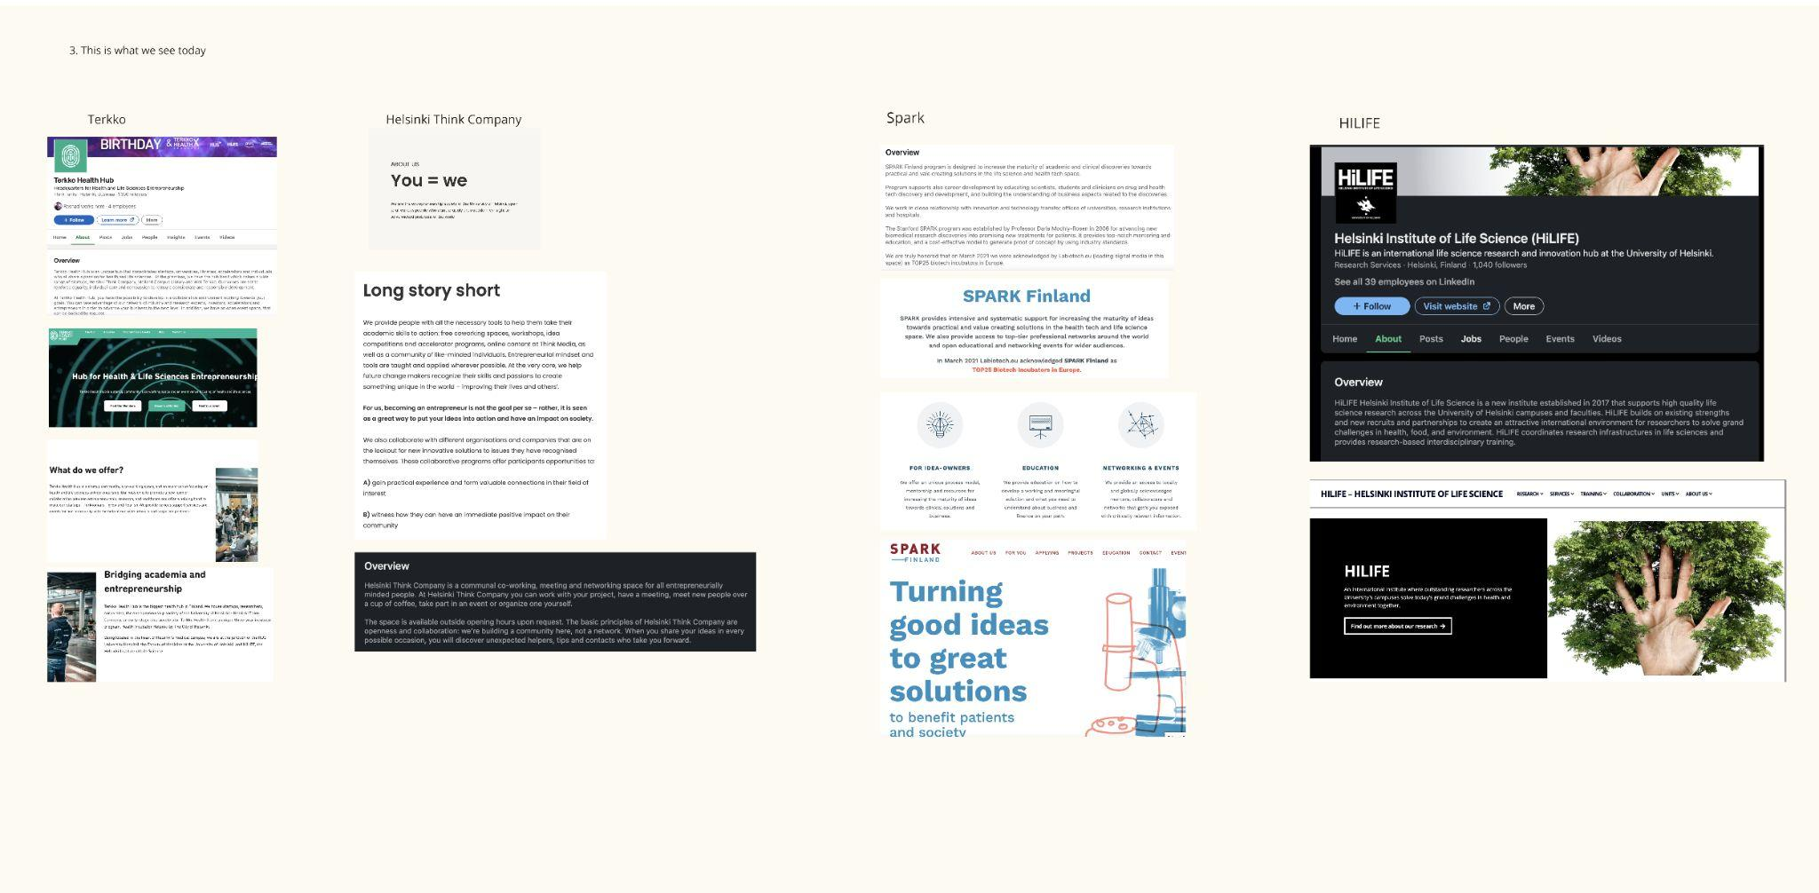

3.7 What are the need of the involved stakeholders customers?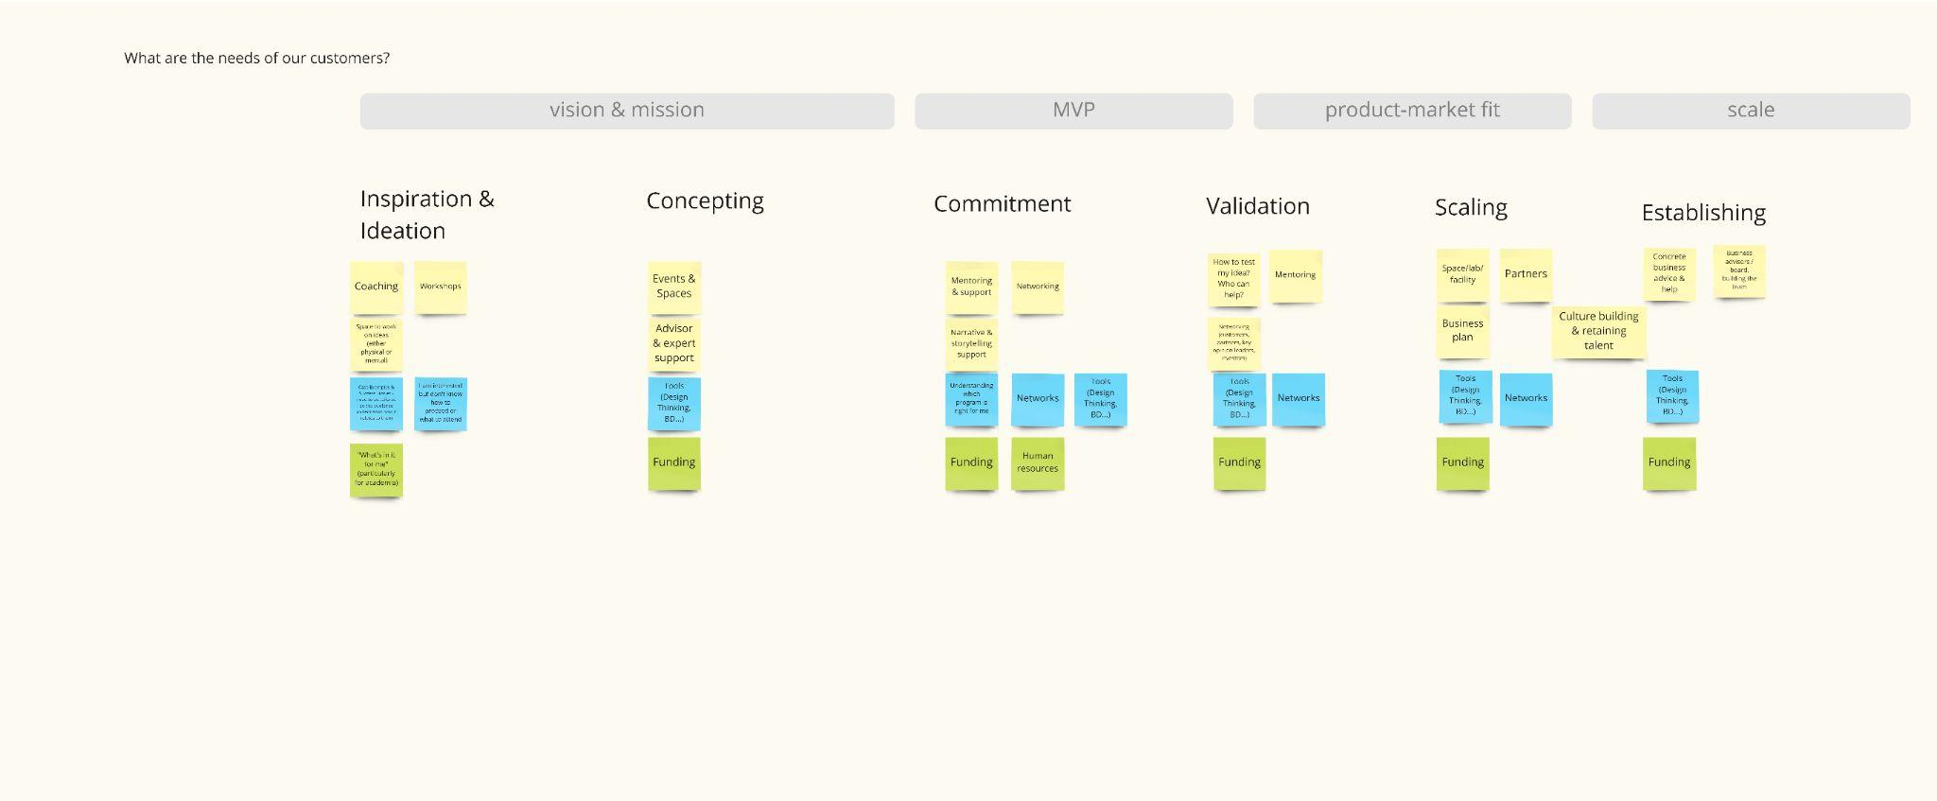

3.8 What do the involved stakeholders provide their customers?