EIT HEI Initiative: EIT Core KPI 8.1 Report

HEI Project Name:

4InnoPipe

Training #1

Title of the education and training activity:

Workshop on incubator learnings and cooperation possibilities held

Start and complete date of the education and training activity (DD/MM/YYYY – DD/MM/YYYY):

26/10/2022

Type of programme:

Workshop

Delivery format (online, on-site, or blended):

Online

Country of delivery (not applicable for online training):

Institution/Organisation(s) delivering the education and training | Country | Is this institution/organisation a consortium member of the HEI project?
University of Helsinki | Finland | YES
Reutlingen University | Germany | YES
Kyiv academic university | Ukraine | YES
Zagreb School of Economics and Management | Croatia | YES

Unique personal identifier per participant (representing the name, contact detail (email address)) | Gender | Country of citizenship | Type of Participant (Student, Academic Staff, Non-Academic Staff) | Did this participant receive further mentoring? Yes/No
Daryna Ivanova | F | Ukraine | Non-academic staff | Yes
Volodymyr Nochvai | M | Ukraine | Non-academic staff | Yes
Alexandra Pravdyva | F | Ukraine | Non-academic staff | No
Mykola Skyba | M | Ukraine | Partner | No
Olga Voropai | F | Ukraine | Non-academic staff | No
Amanda Paananen | F | Finland | Non-academic staff | No
Titta Pirkola | F | Finland | Non-academic staff | No
Thomas Rehmet | M | Germany | Non-academic staff | No
Lyubomyr Matsekh | M | Germany | Academic staff | No
Dubravka Kovacevic | F | Croatia | Non-academic staff | No

Defined learning outcomes for the education and training:

The event was devoted to exchanging best practices of the consortium participants regarding supporting academic startups and collaboration with innovation students and researches teams. Participants have shared the following details of supporting startups at different stages:

- Technological scouting (how to look for innovation ideas and potential startup teams in the University)
- Education approaches (how to raise the awareness about innovation entrepreneurship among technical students, types and formats of educational events, methodology, etc.)
- Formats of organizational structures responsible for supporting academic innovations and their competences
- Peculiarities of working with deeptech innovations
- Formats of communication with private companies as a bridge between innovation teams and investors (formats of collaboration, PR of innovation technologies, readiness of business to invest)
- Perspectives of joint activities by resources of 4 universities in order to build new value added chains.
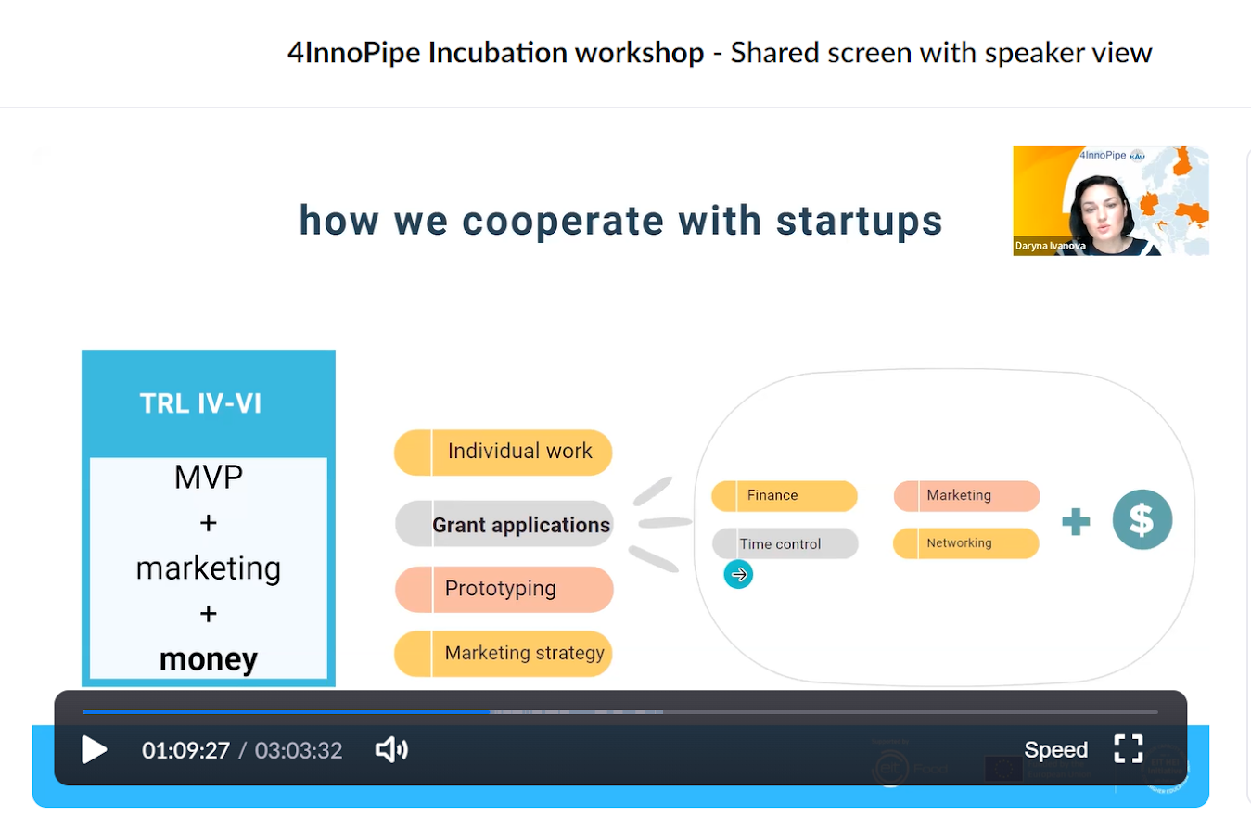

Competence assessment method and results:

Assessment Method(s) | Overall Results e.g. # passed, average scores, or number of qualitative assessments submitted
Self-assessment | Enriched knowledge about possible ways, approaches and formats of developing HEI innovation ecosystems and supporting academic innovation projects.  The event became also a trigger for one-to-one meetings between universities in order to more precisely learn the approaches and infrastructure for developing innovations in the universities-partners.

